

**Student Services  
Assessment and Program Review Guide Using Watermark**

Table of Contents

Program Review and Assessment Cycle -- Overview 2

Service Unit Goals 2

Service Unit Outcomes 2

Starting a Three-Year Cycle 3

Step One: Assessment 3

Step Two: Trend Analysis (Third-year comprehensive review) 3

Step Three: Program Review 3

Standing Requirements (Mission Statement, Service Unit Goals, Service Unit Outcomes Report) 3

Significant Changes, Action Plan, Resource Requests and Status Report 4

Step-By-Step: Access to Watermark Webpage 5

Step-by-Step: Checking Out and Checking In 5

Step-By-Step: Assessment 6

Standing Requirements 6

Input Assessment Cycle 6

Assessment Content Summary 7

Step-By-Step: Program Review 8

Standing Requirements 8

Mission Statement 8

Service Unit Goals 8

Service Unit Outcomes 9

Annual Program Review 9

Significant Changes 9

Action Plan 9

Action Plan: Status Report 9

Resource Request 10

Submitting Program Review 11

Program Review Content Summary 12

# Program Review and Assessment Cycle -- Overview

Each year, the various programs and departments on campus engage in *Program Review*. The term *Program Review* is considered short-term planning. If you are charged with conducting your area’s annual program review, this document will help you understand certain key concepts.

Student Support Services departments work with *Service Unit and/or Learning Outcomes* (SUO/SLO). SUO/SLO’s are statements of operations with measurable outcomes. For instance, “Forms will be current and posted on the departments web page.” These statements include a Measure, such as “all forms will be up-to-date prior to enrollment dates”. These statements and measures should be objectively verifiable.

Program Review (PR) starts with a review of the completed year, then proceeds to possible updates to your goals, SUO/SLO, and future planning in the form of action plans and resource requests:

1. Complete prior year program assessment
2. If this is the start of a new three-year cycle, complete a comprehensive three-year assessment which is called the *3-Year Trend Analysis*
3. Complete your *Program Review* (short-term plan) for the upcoming year.

*Program Review* occurs over a three year cycle, starting with a “full” program review which starts with a comprehensive assessment of the previous three years, after which a mission statement, goals, SUO/SLO and measures are developed or updated. The next two years are updates, where the measures (results) are documented, SUO/SLO adjusted as necessary, and action plans updated based on past year assessments.

A crucial element, and the first step of the *Program Review* is the *Assessment*, where the SUO’s and measures from the prior year’s Program Review are assessed, and status report is entered. During a full program review, every three years, a comprehensive three-year assessment is performed.

## Program Goals

Program goals, in contrast with SUO/SLO, are aligned with College wide strategic goals. Program goals are generally created/updated at the start of a three year Program Review cycle, and are part of the program review workspace. The college’s Strategic Goals are as follows:

1. Provide educational programs and services that are responsive to change and support student learning and success.
2. Deliver educational programs and services in formats and at locations that meet student needs.
3. Enhance the college experience for students and the community by providing student-centered programs, services, and activities that celebrate diversity and sustainable practices.
4. Develop, strengthen, and sustain beneficial partnerships with educational institutions, business and industry, and our community.

## Service Unit Outcomes

In Watermark, SUO/SLOs are called “Operational Outcomes” in the assessment workspace. These outcomes are more closely tied to the day-to-day operations of an area, as compared to the goals which are longer term. The connection between the two is that new goals may generate new day-to-day operations in the service of those goals.

SUO/SLOs are then mapped to the Institutional Student Learning Outcomes, which are:

1. Knowledge of Human Cultures and the Physical and Natural World
2. Intellectual and Practical Skills
3. Personal and Social Responsibility
4. Integrative and Applied Learning

Each SUO has one or more “measures” associated with it, including “acceptable” and “ideal” targets for that measure, along with a timeline. As part of the Assessment phase of Program Review, the outcomes are assessed, according to the set measures, and results are reported (e.g., “Met: Ideal Target”), along with any relevant notes as to why a target was met or not.

# Starting a Three-Year Cycle

When beginning a three year program review cycle, the first step is a comprehensive assessment of the prior three years. For instance, the 2018-2021 program review cycle, begins with a review of the 2015-2018 program review and related assessments. The mission statement and program goals should be reviewed and aligned with college wide Strategic Goals, and may be completely changed, updated or left as is, depending upon the results of the review and any changes to the strategic goals.

## Step One: Assessment

The first step in any cycle is completing your prior year assessment. An individual year’s assessment plan consists of the “Assessment Plan”, “Assessment Findings”, “Action Plan” and a “Status Report”. The Assessment Plan is the definition of measures for each SUO, along with acceptable results. The findings detail what the results were. The next step is planning, where you detail your plans to improve (or maintain) the level of your outcomes. Finally, the status report details the current state of your plans. This can be confusing, at first, because you may have created a new “action” item, so how can there be a status report already? Setting the status for these new items to “not started” or “in progress” is perfectly fine. This assessment step is the same for every year, including comprehensive review years. The assessment step is always the assessment of the prior year. The comprehensive review is in the form of the “Trend Analysis”.

## Step Two: Trend Analysis (Third-year comprehensive review)

The final (third) year assessment in a Program Review cycle will discuss current year outcomes and a three year trend analysis. This is a narrative section where you discuss the entire three-year assessment results, report what has been accomplished, what may need to be discarded, and any new or changed service unit outcomes you feel are needed.

## Step Three: Program Review

### Standing Requirements (Mission Statement, Program Goals, SUO/SLO Report)

The standing requirements consist of your departments’ mission statement, service unit goals and the attached assessment reports which are your service unit outcomes. These form the basis for your three year planning.

All standing requirements are reviewed and updated as needed at the start of each three year cycle, once the prior year assessment and comprehensive review (trend analysis) are complete. Updates to the standing requirements must be based upon the results of the comprehensive review. While the start of a three-year cycle is the traditional point where major updates are made to goals and outcomes, it is worth remembering that these can be changed in *any year* based upon relevant significant changes. Extra care and consideration of your goals and outcomes is certainly called for during the start of a three-year cycle. In addition to your comprehensive review, you should review the college wide Strategic Goals and institutional Student Learning Outcomes, as your goals and outcomes should be driven by, and mapped to those of the institutions’.

### Significant Changes, Action Plan, Resource Requests and Status Report

Other than any changes to the “Standing Requirements”, Program Review proceeds from this point in much the same manner as any year, even at the start of a three year cycle. Remember, the “heavy lifting” has been done in with the comprehensive review and trend analysis, and your standing requirements have now been updated accordingly.

Program review action plans are the steps your department plans to take in furthering of your service unit goals.

Action plans and resource requests are separate sections in the program review template. Action plans are your planned major actions for the next year. If an action plan requires resources from outside your own discretionary budget, you will need to include a “Resource Request” describing the purchase and the amount requested. You do not need to create a resource request for every single item in a “group” purchase. For instance, a smart classroom installation requires many individual purchases, but should be grouped as one resource request. A spreadsheet may be attached to provide a greater level of detail, if needed. Program review and resource requests are an important (and required) source of documentation for extra-budgetary requests.

Action plans will likely carry forward at least one year, since a new action plan will have a status of “not started” or “in progress”. Once the action plan has been marked completed, it does not need to appear in future years.

# Step-By-Step: Access to Watermark Webpage

1. Go to <https://www.watermarkinsights.com/signon/>
2. Enter your login and password
3. Your welcome page will show all assigned workspaces, which are areas with which you have been affiliated. For program review, select the *“Instructional Support Program Review****”*** link under your affiliated program
4. If a password is misplaced, click “Forgot Login?” on the Taskstream sign in page. Then you will need to fill in the appropriate queries and select either: "Email Username & Password Reset" OR "View Password Hint". If you select the email option, note that your username and password information will be sent directly to you at your SDCCD district email. If you have further questions, please contact the Taskstream helpdesk direct via email (help@taskstream.com) or phone at: 1-800-311-5656. Alternatively, you can contact the College-wide Outcomes and Assessment Facilitator who can reset your password for you.

# Step-by-Step: Checking Out and Checking In

To begin entering any information or data in Taskstream, you need to *“Check Out”* the area. Select the *“Check Out”* button to begin work. You may *“Check In”* the area when you complete the work or it will be automatically checked in once you close the browser.

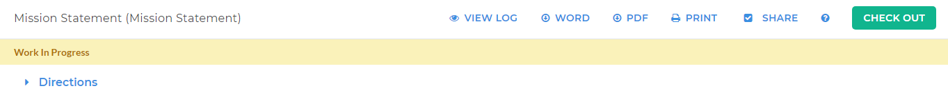

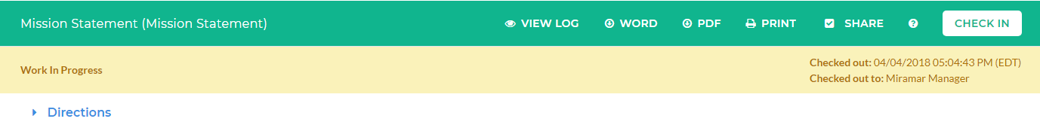

# Step-By-Step: Assessment

## Standing Requirements

1. To enter a Program Mission Statement, select the *“Mission Statement”* link under the Standing Requirements menu on the left. Once you select the “*Check Out*” button, you may enter or update the Mission Statement. Mission Statements should describe the overall mission of your area and how it supports Miramar College’s mission.

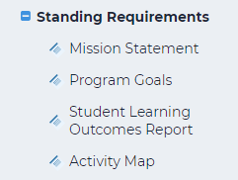

1. Click on *“Program Goals”* and “*Check Out*”. Ensure the following:
   1. You can create new set or select existing set using the buttons towards the top right hand corner
   2. You will input at least 3-5 goals, based on the following components as applicable:
      1. Faculty/Staff
      2. Marketing/Outreach
      3. Budget
      4. Facilities
      5. Operational Effectiveness
      6. Professional Staff Development
      7. Equipment/ Supplies
      8. Community Partnerships
      9. Enrollment Growth/Management
   3. Once you have identified your 3-5 goals, you will add them in the next screen to your Program Goals Set. Click on “Create New Learning Objective”.

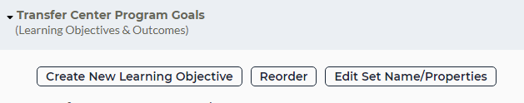

* 1. For the Learning Objective, type “[NAME] Program Goals”. In the “Description” box, type: Program Goals addressing the components listed above (i-ix).
  2. You will title your first Outcome: Goal 1: (Component). Add the actual goal in the description box. Click “Continue”.
  3. If you are adding another Outcome, be sure to label each goal chronologically.
  4. Be sure to map to Miramar’s Strategic Plan Goals. Click on MAP to begin the mapping process



* 1. Click on “PDF” on the bar at the top



Click the drop down menu to export data to a PDF file. Click on “Whole Workspace”, then click continue. This will allow you to create a PDF file of your SLOs that you will upload in the next steps onto your Program Review template.

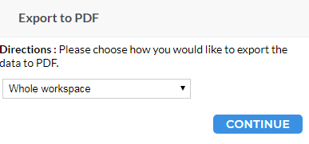

* 1. The Publish page will appear and you will be prompted to identify which pages to publish on your PDF document. Under the Appendix box, choose “Select All” then continue.

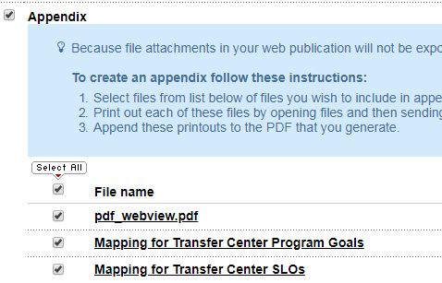

* 1. On the next page, click on “Generate Now”. A new window message will appear, and click OK. Save the PDF file onto your hard drive, where you can easily find and access for a later step. Now click on the Home tab in the top left corner – this will allow you to go back to your Homepage.



1. Now click on the Student Services Program Review 1 template on your Homepage
   1. Click on Student Learning Outcomes Report under Standing Requirements to the left. Check Out. On the bottom of the page, click on “Attachments”.

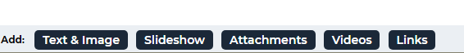

* 1. Click on “Upload from Computer”

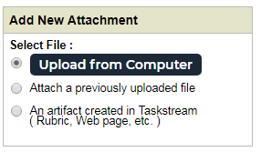

* 1. Add the PDF file of the SLOs you just saved on your harddrive. One added, the PDF file will then appear in the Student Learning Outcomes Report page as designated so that you can view the information of the SLOs workspace as needed and for reference.

1. Under standing requirements, Activity Map, click to see activity plans set for your goals and SLOs

**Program Review Cycle**

For each of the years in program review, you will see:

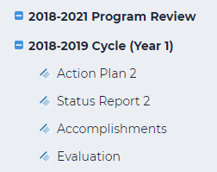

Each year, during the annual update, you will be working on each one of these years

1. Click on Action Plan, Check Out. For each Goal, you will indicate your plan of action or objectives - Click on “Add New Action”
2. Add any supporting attachments.
3. After completing all areas, click on Apply Changes and Check in.
4. After completing each Action Plan for all of your goals, you can move to Status Report. Click on Current Status (select appropriate status for each goal)
5. Click Submit. Repeat for each Goal
6. Click on Status Summary and add a narrative summary of the progress that was made for the reported year. Click Submit once completed.
7. Click on Accomplishments – list your accomplishments for the year. NEW ITEM: include changes/improvements you have made as a result of your evaluations
8. NEW ITEM: At end of year in spring, complete the attached survey

Program Review Content Summary

|  |  |  |
| --- | --- | --- |
| Field in Watermark | Fields to address for Full Program Review (Year 1) | Fields to address for Program Review Cycle Update (Years 2 and 3) |
| Standing Requirements | | |
| Mission Statement | X | Review and update as needed |
| Program Goals | X | Review and update as needed |
| Student Learning Outcomes Report | X | Review and update as needed |
| 3 Year Program Review |  |  |
| Significant Changes | X | X |
| Action Plan | X | X |
| Status Report |  | X |
| Accomplishments |  | X |
| Resource Request |  | X |

# Student Learning Outcomes/Service Unit Outcomes Assessment Workspace Cycle

Click on Student Services Assessment Workspace to begin

Please note that it is required to assess each identified outcome at least once during the 3 year cycle. Assessing during your second year is recommended for all Student Services programs.

Start your 3 year cycle with Standing Requirements

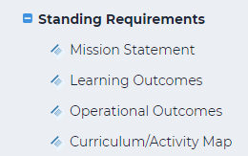

1. Click on Mission Statement, Check Out and enter your Mission Statement. Check In.
2. Click on Learning Outcomes. Check Out. You can create new set or select existing set. Learning Outcomes refers to SLOs



* 1. If you are creating new set, identify a set name and click on “Designate Alignment/Mapping Preference to allow for mapping to ISLO.

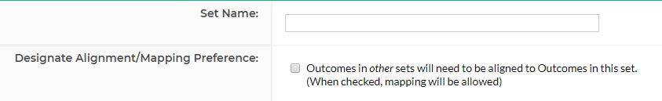

1. For your Outcome Set, create outcomes (SLO). Name your SUO, and be sure to map to ISLO by click on MAP button.



1. Click on Operational Outcomes (SUO). Check Out. You can create new set or select existing set. Not all areas assess Operational Outcomes. SUOs generally refer to satisfaction and efficiency of services versus the actual learning that is taking place.
   1. If you are creating new set, identify a set name and click on “Designate Alignment/Mapping Preference to allow for mapping.



ASSESSMENT CYCLE

1. For each of the years in program review, you will see:

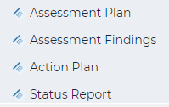

Each year, during the annual update, you will be working on each one of these years

1. Click on Assessment Plan. Check out. If this is your first time in this area, you will need to Create New Assessment Plan or Copy Existing Plan as Starting Point.
   1. Details/Description
   2. Acceptable Target
   3. Ideal Target
   4. Timeline
   5. Key/Responsible Personnel
2. Add any attachments or links that may support your request and remember to “Check in”
3. Click on Assessment Findings. Check Out. You will need to ADD FINDINGS and add the following information:
   1. Summary of Findings
   2. Results
   3. Recommendations
   4. Reflection/Notes
   5. Substantiating evidence (you can attach or link)
4. Check In.
5. Click on Action Plan. Check Out. Add new action or utilizing existing set, add the following information:
   1. Action details
   2. Timeline
   3. Key/Responsible Personnel
   4. Resource Request Type
   5. Budget request amount
   6. Priority
6. Check In
7. Click on Status Report. Check Out. Add Status for each Operational Outcome. Check In.

## Assessment Content Summary

|  |  |  |
| --- | --- | --- |
| Field in Watermark | Fields to address for Full Program Review (Year 1) | Fields to address for Program Review Cycle Update (Years 2 and 3) |
| Standing Requirements | | |
| Mission Statement | X | Matches Program Review |
| Learning Outcomes | X |  |
| Operational Outcomes | X | Review and update as needed |
|  | X |  |
| Assessment Cycle |  |  |
| Assessment Plan | X | X |
| Assessment Findings | X | X |
| Action Plan | X | X |
| Status Report | X | X |

# Step-By-Step: Program Review

## Standing Requirements

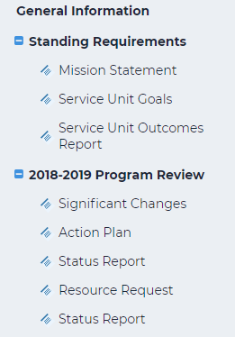There are three standing requirements for Program Review. Your mission statement, your service unit goals, and your service unit outcomes. The outcomes are simply resulting report from your assessment phase. The standing requirements are the first (top) section of the program review template:

### Mission Statement

To enter a Program Mission Statement, select the *“Mission Statement”* link under the Standing Requirements menu on the left. Once you select the “*Check Out*” button, you may enter or update the Mission Statement. Mission Statements should describe the overall mission of your area and how it supports Miramar College’s mission.

### Service Unit Goals

To enter Service Unit Goals, click on *“Service Unit Goals”* and “*Check Out*”. Ensure the following: For a full program review conducted at the beginning of the 3 year cycle, input the program goals that you will be addressing over the next 3 year period. You may want to review the Service Unit Outcomes from the last cycle to help you with your goals. Keep in mind you will have the opportunity to revise, delete, or add goals as you proceed through your 3 year cycle. If you have the same goals from the last cycle, you can choose to copy over an existing set of goals. Click on “Create New Outcome” (1) to insert new outcomes. Be sure to map to Miramar’s Strategic Plan. Click on MAP (2) to begin the mapping process.

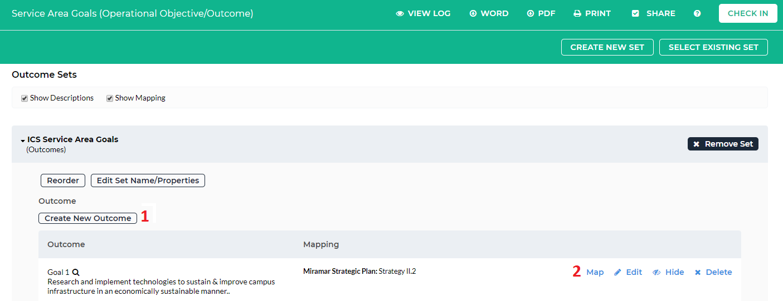

### Service Unit Outcomes

Click on your Service Unit Outcomes Report, then on “Check Out” in the top right hand corner in green. Towards the bottom of your screen, you will see:



Click on Attachments and upload your Annual Update document and remember to click “Check In”

## C:\Users\khill\Desktop\Screen Shot\PR Menu.PNGAnnual Program Review

You will see three similar sections, one for each year in the three-year cycle, for your annual program review. Each year, during the annual update, you will be working on each one of these years:

### Significant Changes

Click on Significant Changes and “Check Out”. This area is an opportunity for you to highlight the needs that arose from your last cycle, both Program Review and Assessment and discuss the significant changes from the previous year. “Check in”

### Action Plan

Click on Action Plan. Check out. If this is your first time in this area, you may need to “SELECT SET” and click on the program goals you developed in the “Service Unit Goals” in Standing Requirements. For each of your goals, add an action using the “Add New Action” button. You will be asked to:

1. Describe your action and how it relates to your goals.
2. Identify a timeline
3. Identify key/responsible personnel
4. Indicate the relative priority
5. Add any attachments or links that may support your request and remember to “Check in”.

### Action Plan: Status Report

Click on Status Report. Check Out. Here, you will find your program goals and action plans you developed. Click on ADD STATUS and input the following for each of your goals:

1. Current Status
2. Additional Information and/or Status Summary
3. Next Steps
4. Substantiating evidence (you can attach or link)

### Resource Request

Click on “Resource Request” and check it out. If this is your first time, you will need to select the same goal set as you did for your action plan. Here you will enter the following information for each funding request you wish to submit to BRDS:

1. A description of the resource request
2. The quantity required
3. A priority rank
4. Whether the item affects saftey, certification or accreditation
5. Any impact to other support areas
6. The total amount requested
7. Any supporting documents

## Submitting Program Review

Utilizing Watermark will help streamline our Program Review submission process, by allowing areas to publish the Program Review Report and share the information by providing the link to your dean/manager as appropriate.

1. To begin, select the *“Publish”* tab from the top of the *“Instructional Support Program Review”.*

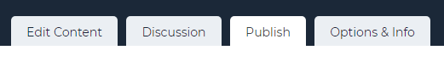

1. Follow the prompts and then publish the workspace to a webpage by selecting the *“Publish”* link and forward the URL to your appropriate manager.

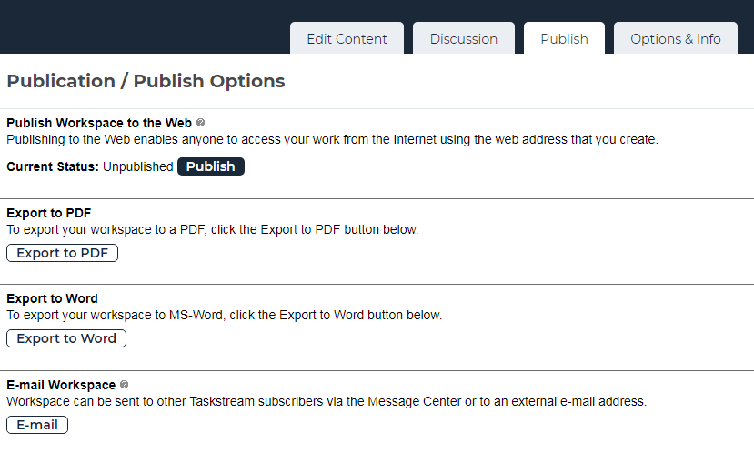

## Program Review Content Summary

|  |  |  |
| --- | --- | --- |
| Field in Watermark | Fields to address for Full Program Review (Year 1) | Fields to address for Program Review Cycle Update (Years 2 and 3) |
| Standing Requirements | | |
| Mission Statement | X | Review and update as needed |
| Service Unit Goals | X | Review and update as needed |
| Service Unit Outcomes Report | X | Review and update as needed |
| 3 Year Program Review |  |  |
| Significant Changes | X | X |
| Action Plan | X | X |
| Status Report | X | X |
| Resource Request | X | X |